Chicken pie

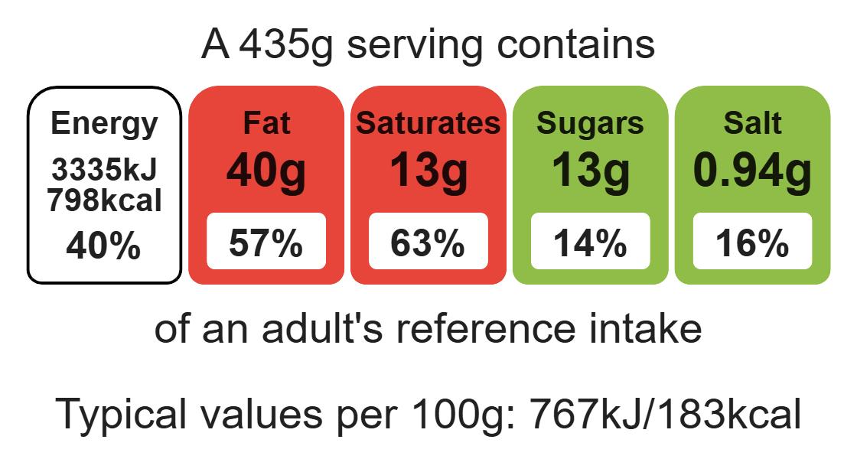
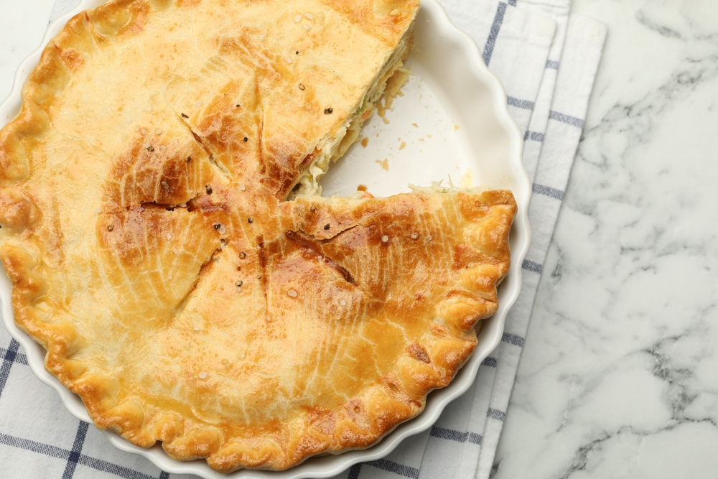

Ingredients (serves 2)
1x15ml spoon vegetable oil
2 chicken breasts
6 mushrooms
1 onion
25g frozen peas
25g sweetcorn (canned or frozen)
1 x quantity white sauce
1 x quantity shortcrust pastry

Equipment

Weighing scales

Chopping board x2

Sharp knife

Frying pan

Saucepan

Mixing bowl

Measuring jug

Measuring spoons

Sieve

Palette knife

Fork

Pastry brush

Pie dish

Flat baking tray

Complexity: high

Method
1. Preheat oven to 200ºC, gas mark 6.
2. Make up the shortcrust pastry. Allow to rest.
3. Prepare the vegetables on a clean chopping board using a sharp knife:
- peel and chop the onion;
- slice the mushrooms.
4. Heat the oil in a frying pan. Add the onion and fry for 5 minutes.
5. Cut the chicken into chunks using a clean chopping board and sharp knife.
6. Add the chicken and cook for a further 5 minutes.
7. Add the mushrooms, peas and sweetcorn. Reduce the heat and cook for a further 5 minutes.
8. Make the white sauce, with mixed herbs.
9. Stir the sauce with the chicken mixture, remove from the heat.
10. Lightly grease a pie dish.
11. Remove the pastry from the fridge and divide the pastry into 2.
12. Roll out the pastry thinly on a lightly floured surface, large enough to cover the pie dish
13. Carefully place the pastry into the greased dish. Ensure that the pastry sits well in the dish.
14. Trim away the excess pastry around the edges.
15. Prick the base with a fork.
16. Pour the chicken mixture into the dish.
17. Brush the edges of the pastry with milk or water.
18. Roll out the remaining pastry thinly to make the pie top, and place on top.
20. Trim away the excess pastry around the edge.
21. Secure the edges by pressing down with a fork.
24. Make an air vent in the centre of the pie lid.
25. Glaze the top of the pie with milk and bake for 20-25 minutes, or until golden brown.

Top tips
- Focus on fibre: swap plain flour for wholemeal flour in your shortcrust pastry. Be aware you may need to add more liquid as a result.
- For a vegetarian alternative: replace the chicken with beans, lentils or pulses.

Food skills
Weigh, measure, cut, chop, slice, dice and trim, fry and sauté, melt, simmer and boil, whisk, rub-in, portion/divide, roll out, decorate and garnish, glaze and coat, bake.

