Bacon and mushroom risotto

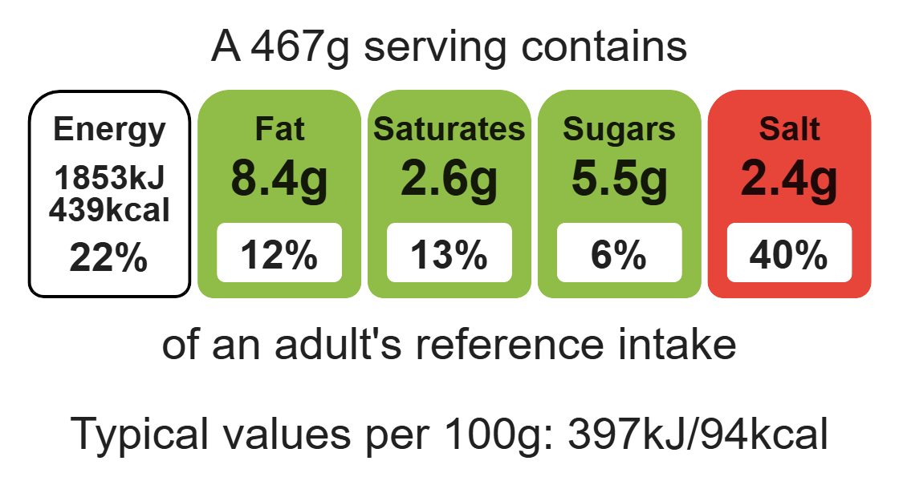
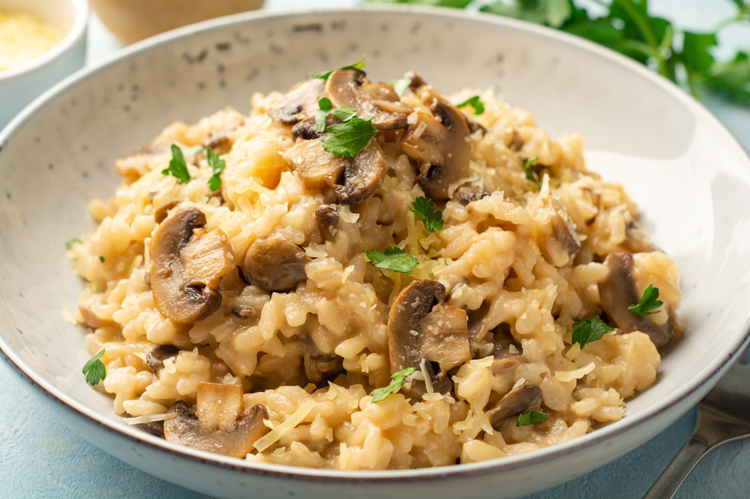

Ingredients (serves 2)
150g risotto rice
1 reduced-salt vegetable stock cube
600ml water
1 x 5ml spoon parmesan cheese
Black pepper
1 onion
6 lean bacon rashers
50g mushrooms
100g green beans
1 x 5ml spoon oil
Complexity: medium

Equipment

Weighing scales

Sharp knife

Chopping board x2

Grater

Measuring spoons

Heat-resistant spoon

Measuring jug

Kettle

Frying pan

Method
- Prepare the ingredients for the risotto on a clean chopping board using a sharp knife:
- peel and chop the onion;
- chop the green beans in half;
- slice the mushrooms;
- grate the parmesan cheese;
- on a clean chopping board, chop the bacon into large chunks.
- Heat the oil in a saucepan and fry the bacon and onion together.
- Add the mushrooms and green beans and fry for another 2 minutes.
- Stir in the rice.
- Make up the stock.
- Add the stock a little at a time, stirring constantly and allowing the rice to absorb the stock before adding any more liquid.
- Continue adding the stock until the rice is cooked – this will take 20-25 minutes. The rice should be soft but still retain a nutty bite.
- Finally, stir in the parmesan cheese and some black pepper into the rice.

Top tips
- Serving suggestion: sprinkle with parmesan cheese and top with rocket leaves to serve.
- Focus on fibre: consider using brown risotto rice to increase the fibre content of the dish.
- Turn up the flavour: season your risotto well, consider adding herbs such as parsley, oregano and basil.
- Reduce food waste: use up any leftover vegetables in your risotto e.g. leeks.

Food skills
Weigh, measure, peel, cut, chop, slice, dice and trim, grate fry and sauté, mix, stir and combine.

